**Sandscapes:**

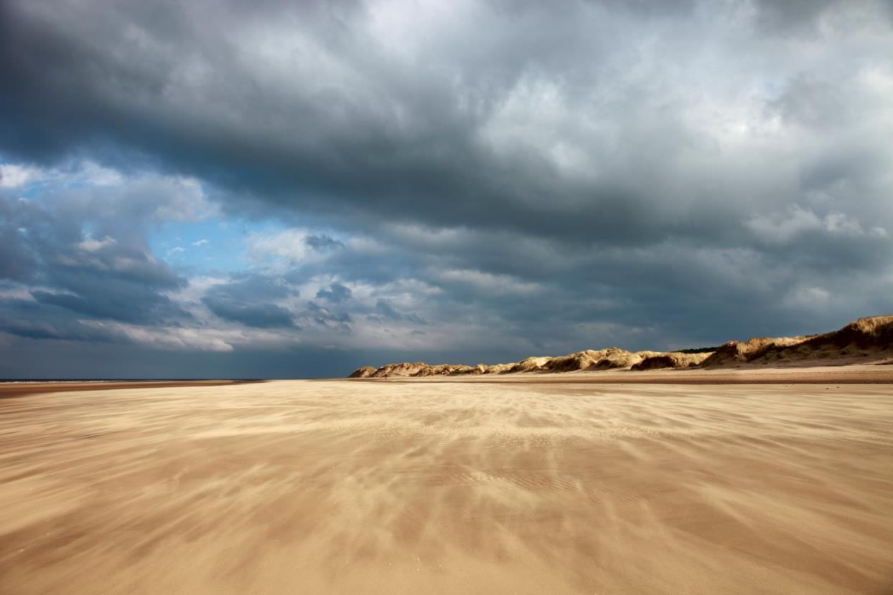

Image © Dave McAleavy Images

**Celebrating the Natural and Cultural Capital**

**of Coastal Landscapes**

**11th & 12th October**

**The Atkinson, Southport**

**A Joint North West Coastal Forum & Sefton Coast Landscape Partnership Event**

**Conference Chair:Paul Nolan**

**Director, Mersey Forest & Chair, Sefton Coast Landscape Partnership**

**The North West’s Biennial Coastal Conference Featuring the**

**North West Awards for Coastal Excellence 2016**

**Why hold this conference?**

Cultural and natural capital are increasingly being recognised as key drivers for economic growth and sustainable development. This is reflected in a range of policy and strategy coming forward both locally and nationally. Working in partnership at the landscape scale is recognised as a valuable approach to managing complex wide-scale issues. It shares many aspects of integrated coastal management and so can be particularly useful in a coastal setting where the dynamic nature of the coast and its natural processes pose particular challenges – and opportunities – for local communities, coastal managers and everyone who visits and enjoys the coast.

The Sefton Coast Landscape Partnership Scheme ran from 2011 to 2015 and was a great success, raising the profile of natural and cultural coastal assets and getting local people involved in exploring, recording and enjoying the richness of Sefton’s coastal heritage. Morecambe Bay’s Headlands to Headspace is still running and is another great North West example of this kind of partnership working, and there are other great examples elsewhere such as Touching the Tide in Suffolk. Accordingly this conference and its associated field trip are designed to:

* Demonstrate the benefits of working at the landscape scale and in partnership by showcasing the work and achievements of coastal Landscape Partnerships:
  + The Sefton Coast Landscape Partnership
  + Headlands to Headspace – Morecambe Bay’s Landscape Partnership
  + Touching the Tide – Suffolk Coast Area of Outstanding Natural Beauty’s Landscape Partnership
* Explore the value of the natural and cultural assets of the coast and their links to growth, prosperity and wellbeing, explaining the concept of natural and cultural capital and ecosystem services and how these can be used.
* Celebrate the achievements of individuals, community groups and organisations/businesses with the North West Awards for Coastal Excellence – categories include Coastal Champion, Coastal Community Action and Coastal Best Practice

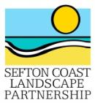**What will you get out of the conference?** You will gain a greater understanding of the value of working in partnership at the landscape scale and the concepts of natural and cultural capital and ecosystems services. We hope you will be inspired by the work of the partnerships and what they have achieved, and by the work and commitment of the NW ACE winners. On Tuesday the 11th October there will be an optional field trip to the Sefton coast to see the coastal landscape and its assets and challenges, and discuss the SCLP achievements with the project staff and partner organisations, in particular the National Trust who are hosting a guided walk. There will also be an informal networking dinner.

**Who should attend?** Businesses, communities and visitors to the coast, including other Landscape Partnerships, tourism and recreation businesses, politicians, public sector officers, Local Enterprise Partnerships, Local Nature Partnerships, NGOs and all involved with the day to day management of the coast and its natural and cultural assets.

**Organised by the** [**North West Coastal Forum**](http://www.nwcoastalforum.org.uk/)a multi-sector non-profit partnership working together across boundaries to deliver economic, social and environmental benefits for coastal communities in North West England & the [**Sefton Coast Landscape Partnership**](http://www.visitsouthport.com/things-to-do/seftons-coast/landscape-partnership-scheme)**.**

**Cost – Free** The field trip on the 11th and the conference on the 12th are both **FREE** to attend. If you book a place and find you are unable to attend please let us know as soon as possible as space is limited. Please note we reserve the right to charge a cancellation fee of £75 for cancellations made less than 5 working days before the event (substitutes will be accepted but may not be included on the delegate list)

**Conference Dinner** There will be an opportunity to join other delegates for an informal networking dinner on the evening of the 11th. There will be a cost for this which will need to be paid in advance. Please indicate below if you are interested in attending the dinner (NB you will be contacted again with the exact price before a firm booking is taken).

**Sponsorship, Exhibitions, Delegate Pack Inserts** Please indicate below if you wish to receive details (a scale of charges applies)

**Venue** The conference venue is [**The Atkinson**](http://www.theatkinson.co.uk/visit-us/plan-your-visit/getting-here/) – Southport’s flagship home for music, theatre, art, poetry, literature and history. The Atkinson is centrally positioned on Lord Street, just 3 minutes’ walk from the train station. Significant investment has been made in refurbishing the 19th century buildings, to create a multi art-form venue with a strong contemporary feel. The redevelopment was completed by the opening, in February 2015, of **Between Land and Sea – 10,000 Years of Sefton’s Coast – a new permanent exhibition which tells** the story of Sefton and how the coast has influenced its development over time. Delegates will have an opportunity to view this during conference breaks.

**Accommodation** There is a wide range of accommodation to suit all budgets in Southport. Please see [**Visit Southport**](http://www.visitsouthport.com/accommodation) for more information.

Registration Form

###### Please complete **1 form for each delegate** in **block capitals** and **return by Friday 7th October** to:

###### **Address:** Coast & Countryside, Sefton Council, Ainsdale Discovery Centre, The Promenade, Shore Road, Ainsdale, Southport PR8 2QB

###### **Fax:** 01704 575628

###### **Email:** [info@nwcoastalforum.org.uk](mailto:info@nwcoastalforum.org.uk)

###### Any queriestelephone Caroline (North West Coastal Forum): 0151 934 2966

**Delegate Name:**

**Job title:**

**Organisation:**

**Address:**

**Telephone:** **Email:**

**If not already on the North West Coastal Forum mailing list do you want to be included on it? Yes / No**

(details held for non-commercial use and will never be shared with other organisations without first seeking

your explicit consent)

**Please indicate any special dietary or other requirements in the space below:**

**Field Trip Tuesday 11th October:** This is a full day field trip to the Sefton coast and involves long walks on rough

terrain. Numbers are limited and space will be allocated on a first come, first served basis. Do you wish to join us? **Yes / No**

**Conference Dinner Tuesday 11th October** (a cost applies):Please send me further details **Yes / No**

**Exhibition / delegate pack inserts** (costs apply): Please send me further details **Yes / No**

**Sponsorship opportunities:** Please send me further details **Yes / No**

**Please note:**

1. It may be necessary for reasons beyond our control to change the venue, content, speakers or timing of the programme. Where this happens we will make every effort to let you know as soon as possible
2. Except in the event of a major change to the content, location or timing we reserve the right to charge a cancellation fee of £75 for cancellations made less than 5 working days before the event (substitutes will be accepted)