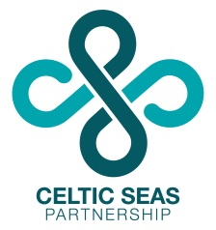
Provisional Programme

09:30 Registration and refreshments
10:00 Welcome
Celtic Seas Partnership update Jenny Oates, Project Manager
Update on MSFD implementation in England Dominic Pattinson, Defra
Future Trends - sector perspectives
Ian Godfrey, Regen SW
Professor Phil Leigh, Irish Sea Rim & University of Chester
Questions
Refreshments
Future trends
Mapping issues and gathering information to build future scenarios of sectoral growth and development in the Celtic Seas
Introduction Penny Wilson, Policy Officer
Discussion session
Lunch
Developing tools to meet future challenges
Best practice guidelines and case studies to help achieve Good Environmental Status (GES)
14:00 Plenary introduction Caroline Salthouse, NW England Stakeholder Engagement Officer
Guidelines for terrestrial planning and the Marine Strategy Framework Directive
Sue Kidd / Lynne McGowan, University of Liverpool
Discussion session in break-out groups
- Trans-boundary marine governance
- Co-location of marine renewables with other marine users and interests
- Conflict resolution and sectoral interaction between different marine users/interests
- Guidelines for terrestrial planning & the Marine Strategy Framework Directive
Refreshments
Stakeholder-led initiatives for GES – Update on the CSP MSFD Task Groups work
The SW & Wales Stakeholder Engagement Officer (tbc)
Introduction to the Celtic Seas Partnership’s MSFD ‘Strategic Overview to Discovering Marine Strategy Framework Directive Data and Information in the Celtic Seas’
Dr Tim O’Higgins, MaREI
Questions
Next steps & closing remarks
16:30 Workshop close

