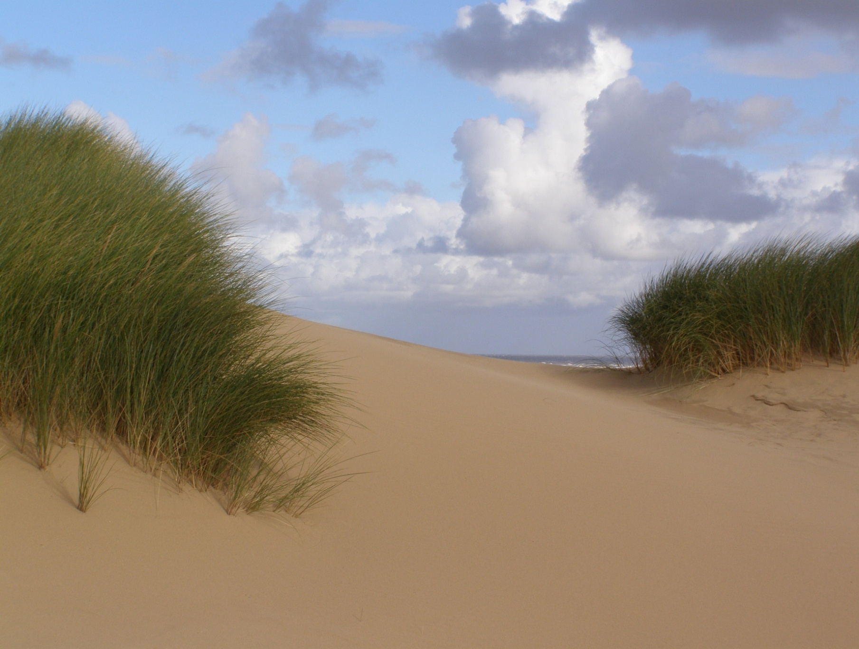Conference Chair*:*

Peter Hampson, CEO, British Destinations

3rd and 4th November, Grange-over-Sands

*Destination* *Coast!*

*The North West’s Biennial Coastal Conference featuring the*

North West Awards for Coastal Excellence 2014

**Why hold this conference?**

In February 2014 the European Commission released a Communication on a European Strategy for more Growth and Jobs in Coastal and Maritime Tourism as part of the European Blue Growth agenda. Here in the UK there is an increasing focus on the ‘staycation’, and to encourage people to take longer breaks in the UK instead of going abroad, while short breaks, recreation-based or activity holidays and day visits continue to contribute strongly to within-UK tourism. The North West coast offers a wealth of opportunities, from the traditional resort holiday to extreme sports. Accordingly the aims of this event are to:

* **Share information about tourism and leisure issues and opportunities** with direct relevance to the north west coast including key policy and legislative drivers and examples of innovative projects and best practice
* **Provide a launch pad for developing positive action** to safeguard and improve the North West’s coastal visitor offer
* **Inspire businesses and other organisations**, small and large, to reap the economic benefits of our fantastic coastal resource by developing quality of offer, improving sustainability in business operations and making the most of opportunities to promote the value and benefits of tourism, recreation and leisure on the coast

**What will you get out of the conference?** You will gain a greater understanding of some of the key policy drivers for the coastal visitor economy and hear about inspirational examples of how to develop and maximise opportunities from within the region and elsewhere. On the morning of Tuesday 4th November there will be an optional field trip to Morecambe Bay to see and discuss some of the inspiring tourism and recreation work being done by the Morecambe Bay Partnership and their partners.

**Who should attend?** All those with an interest in developing and maximising the value of the visitor offer of the North West coast: leading tourism and recreation businesses and business organisations, key decision makers such as politicians, local authority and Government Agency officers, Local Enterprise Partnerships and those tasked with the day to day management of the coast and its visitor attractions.

**Organised by the** [**North West Coastal Forum**](http://www.nwcoastalforum.org.uk/)a multi-sector non-profit partnership working together across boundaries to deliver economic, social and environmental benefits for coastal communities in North West England.

**Costs\*** Public or private sector: £50; Non-profit organisation/Charity: £30; Member of the public/unwaged/student: Free.

*Traditionally NWCF events have always been free but with austerity this is becoming more difficult. We don’t want to stop you from attending so if the amount suggested above is just not possible contact Caroline for one of the limited free places.

**Venue & Accommodation** The conference venue – the 4* [**Grange Hotel**](http://www.grange-hotel.co.uk/) - is situated just less than 5 minutes walk from Grange-over-Sands railway station. We have provisionally held a number of rooms at £74 single, £125 double/twin b&b for the nights of 2nd & 3rd November (this rate is also available on 4th for those also attending the Coastal Partnerships Network event). Please book direct with the hotel 01539 533666 quoting ‘coastal conference’ to get these rates. Alternative accommodation is available nearby – see [**Visit Cumbria**](http://www.visitcumbria.com/south-cumbria-holiday-accommodation/)

**Sponsorship, Exhibitions and Delegate Pack inserts** Opportunities exist, contact Caroline on 0151 934 2966

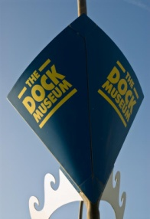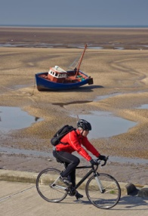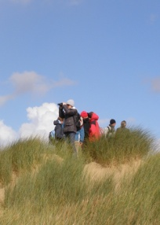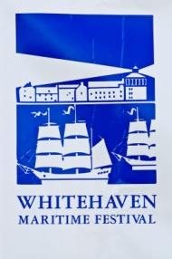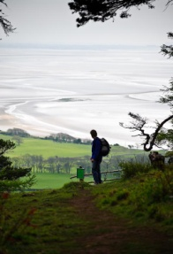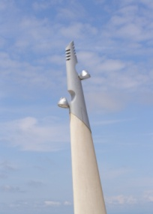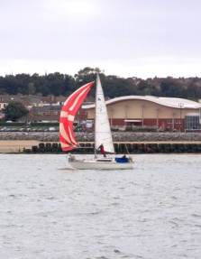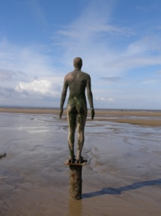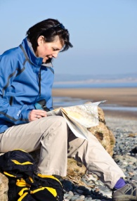

*All images © Dave Willis mountainsportphoto.com or Caroline Salthouse*

*Destination Coast!*

3rd & 4th November 2014, Grange-over-Sands

Provisional Programme

Monday 3rd November

**10:00 Registration**

**10:25 Welcome -** Conference Chair: Peter Hampson, Chief Executive, British Destinations

**10:30 Opening Keynote: Seaside Towns in the Age of Austerity – Recent Trends in Employment in Seaside Tourism in England and Wales - Professor Steve Fothergill, Sheffield Hallam University**

**11:10 The European Agenda for Blue Growth and the Coastal Visitor Economy -** Caroline Salthouse, North West Coastal Forum

**11:30 Questions**

11:35 Refreshments and networking break

**11:55 Improving the North West’s bathing waters: The work of the Turning Tides Partnership -** Clare Nolan Barnes, Head of Coastal & Environmental Partnership Investments, Blackpool Council & Emma McColm, LOVEmyBEACH Officer, Morecambe Bay Partnership

**12:35 Questions**

**12:40 The North West Awards for Coastal Excellence – celebrating examples of good practice and inspirational people from around the North West -** Awards presented by Peter Hampson, Chief Executive, British Destinations, Information on the winning entries - Caroline Salthouse, North West Coastal Forum

13:00 Lunch and networking break

**14:00 Making the Most of Natural Assets: Morecambe Bay Nature Tourism Business Network -** Jenny Wain, NW Futurescapes Senior Officer, RSPB & Roger Carter, Chair, Bay Tourism Association

**14:20 Animating the Mythic Coastline –** Chris Wyatt, Arts & Events Development Officer, Wyre Council

**14:40 Cumbria Tourism – leisure opportunities around the coast –** Richard Greenwood, Head of Operations, Cumbria Tourism

**14:55 Questions**

15:00 Refreshments and networking break

**15:30 Wales Activity Mapping: a tool to enhance sustainable management of coastal recreational activity and identify new opportunities -** David Jones, Pembrokeshire Coastal Forum

**15:50 Closing Keynote**: **Destination Morecambe Bay – not your average bucket and spade resort -** Susannah Bleakley, Executive Director, Morecambe Bay Partnership

**16:20 Questions**

**16:25 Closing remarks -** Conference Chair: Peter Hampson, Chief Executive, British Destinations

16:30 Conference close

Tuesday 4th November

**10:00 Field Trip Registration**

**10:20 Destination Morecambe Bay!**

Optional Field Trip to Barrow and Walney led by Susannah Bleakley & Janet Barton, Morecambe Bay Partnership with Caroline Salthouse, North West Coastal Forum

13:00 Lunch and close

*It may be necessary for reasons beyond control of the North West Coastal Forum to change the venue, content, speakers or timing of the programme*

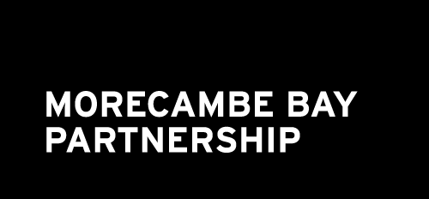

Registration Form

*Destination Coast!*

3rd & 4th November 2014, Grange-over-Sands

###### **Please complete 1 form for each delegate in block capitals and return before 27th October to:**

###### Caroline Salthouse, North West Coastal Forum, Sefton Council, Magdalen House, 30 Trinity Road, Bootle L20 3NJ

###### Telephone: 0151 934 2966 Email: [info@nwcoastalforum.org.uk](mailto:info@nwcoastalforum.org.uk)

Confirmation and further details will be sent out in the week before the event.

**Delegate Name:**

**Job title:**

**Organisation:**

**Address:**

**Telephone:** **Email:**

**If not already on the NWCF mailing list do you want to be included on it? Yes / No**

*(details held for non-commercial use and will never be shared with other organisations without first seeking your explicit consent)*

**Please indicate any special dietary or other requirements in the space below:**

**Field Trip:** The field trip is included in the conference cost but because it is shared with the Annual Coastal

Partnerships Network Annual Forum it would be helpful to know if you plan to join us on the morning

of Tuesday 4th November to ensure we have enough transport. **Yes / No**

**Exhibition / delegate pack inserts** (additional cost may apply): Please send me further details **Yes / No**

*Paying exhibitors will receive 1 delegate place free*

**Please invoice me for £**

* Member of the public/unwaged/student: **free**; Non-profit organisation/Charity: £30; Public or private sector: £50
* *Exhibitors please call/email Caroline to discuss as exhibition charges include 1 free delegate place*
* *If you wish to pay for more than one delegate please call/email Caroline to discuss*
* *Please note there is no reduction for attending only part of the event (including the field trip)*
* *Refunds, minus a £10 administration charge, will only be issued to delegates cancelling more than 7 working days before the event; substitutes will be accepted but where possible 7 days advance notice should be given.*
* *There will be a £30 charge to anyone on a free place who cancels less than 7 working days before the event (substitutes accepted)*

**Purchase order or reference number:**

*IMPORTANT: Purchase orders should be made out to Sefton Council who will issue the invoice on our behalf*

**Invoice name and address and contact person (including telephone) if different from above:**

Stop Press! Coastal Partnerships Network Annual Forum 2014 Tuesday and Wednesday 4th &5th November

Why not make the most of your visit to Grange-over-Sands and also register for the *Coastal Partnerships Network Annual Forum 2014*, a 2-day national coastal policy and networking event which shares the field trip and immediately follows *Destination Coast!* at the same venue. See [North West Coastal Forum](http://www.nwcoastalforum.org.uk/) or contact Caroline on 0151 934 2966. Cost savings for those exhibiting at both events.