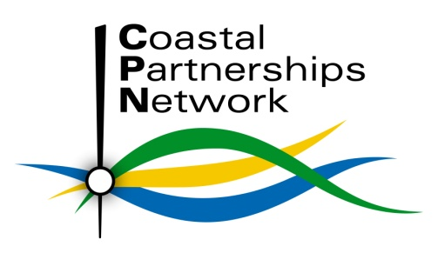

Coastal Partnerships Network

Annual Forum 2014
4th & 5th November, Grange over Sands

Conference Programme

Tuesday 4th November

Day 1 Chair: Niall Benson, Durham Heritage Coast & Chair of the Coastal Partnerships Network

10:00 Field Visit Registration

10:20 Destination Morecambe Bay!
Optional Field Trip to Barrow and Walney Island led by Susannah Bleakley & Janet Barton, Morecambe Bay Partnership with Caroline Salthouse, North West Coastal Forum

13:00 Conference Registration and Lunch at Grange Hotel

13:45 Welcome and Introduction to the Conference
Niall Benson, Durham Heritage Coast & Chair of the Coastal Partnerships Network

13:55 An introduction to the work of the local coastal partnership: Morecambe Bay Partnership – a small charity making BIG things happen for our communities
Susannah Bleakley – Morecambe Bay Partnership

WATER currents

14: 25 Social Impacts and Interactions in the Marine Sector & Progress on English Marine Plans
Hannah Marriott, Marine Management Organisation

14:55 River Basin and Flood Risk Management Planning
Paul Parker and colleague, Environment Agency

15:25 Questions

15:30 Coffee, Exhibitions, Networking

Marine movements
16:00 Marine Protected Area Management and Governance
Jan Maclennan, Natural England

16:20 Marine Protected Areas – Conservation Advice and Management
Jamie Davies, Natural England

16:40 Marine Litter Network
Emma Cunningham, Marine Conservation Society

17:20 Questions

17:30 Summing up day 1
Conference Chair

19:30 Conference Dinner

Wednesday 5th November

Day 2 Chair: tbc

09:00 Registration and refreshments

09:30 Welcome
Session Chair

NAVIGATING POLICY & DELIVERY

09:15 ICZM in England
Steve Collins, Defra

09:40 A Scottish Perspective
Lady Isabel Glasgow, Chair, Scottish Coastal Forum

10:00 Counting our Coast – Citizen Science in Action
Dr Jane Delany, Newcastle University

10:25 Marine CoLABoration
Amy Pryor, Thames Estuary Partnership

10:45 New Ways of Working – Community Enterprise in Reality
David Jones, Pembrokeshire Coastal Forum CIC

11:10 Questions

11:15 Refreshments, Exhibitions, Networking

STEAMING AHEAD

11:30 Coastal Partnerships Network – Chair’s Report
Niall Benson, Durham Heritage Coast

11:15 Workshop exploring:
- Collaborative opportunities
- New operating mechanisms
- Action planning for the next 12 months

12:15 Workshop feedback
Rapporteurs

12:30 Open discussion on workshop feedback
Everyone!

12:45 Summing up and main conference close
Conference Chair

12:50 CPN Business Meeting

13:00 Lunch and depart

The Coastal Partnership Network would like to thank all our speakers for their time and effort in preparing and presenting.
The event cannot succeed without this support.

It may be necessary for reasons beyond control of the Coastal Partnerships Network to alter the content and timings

