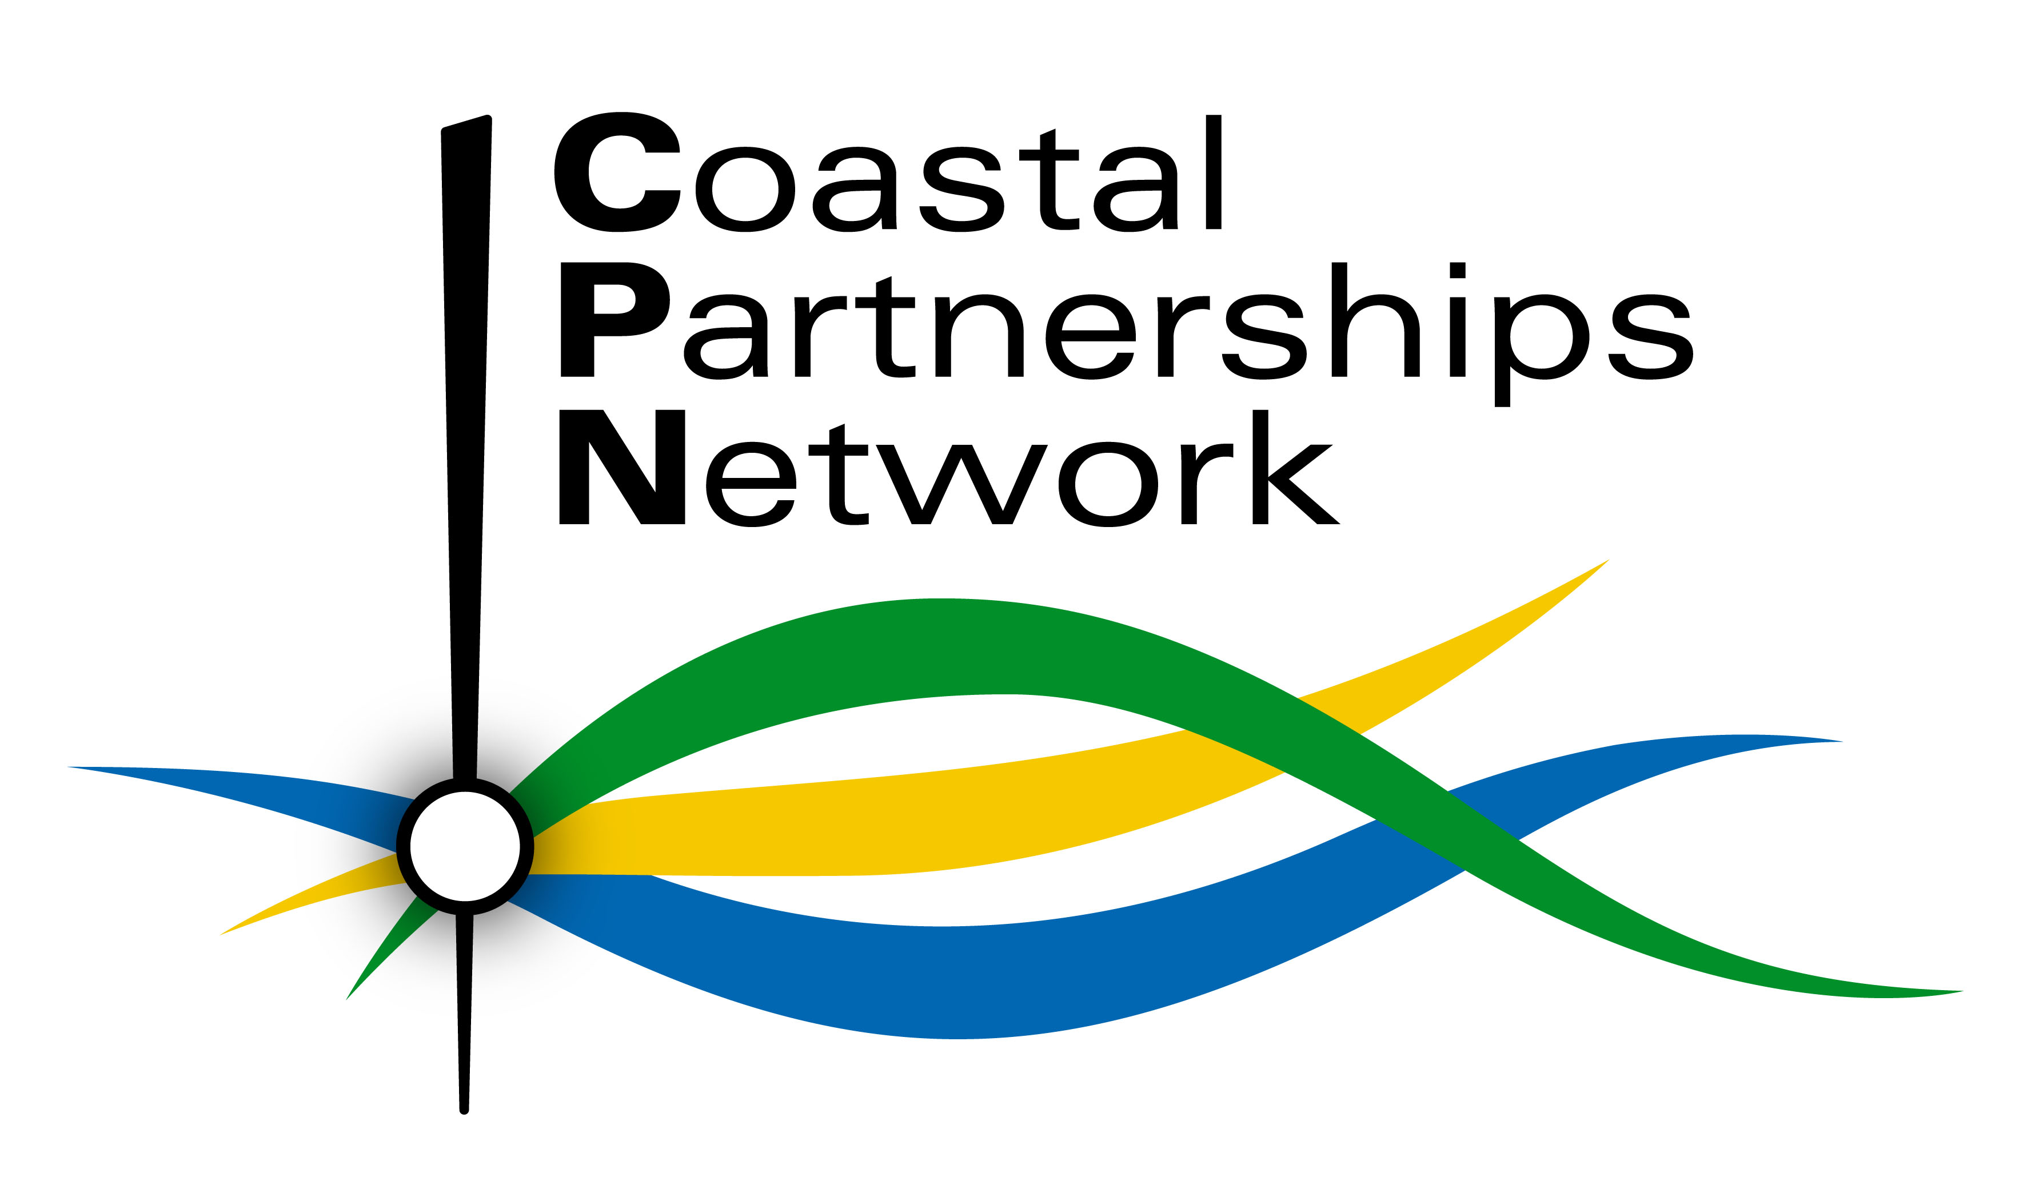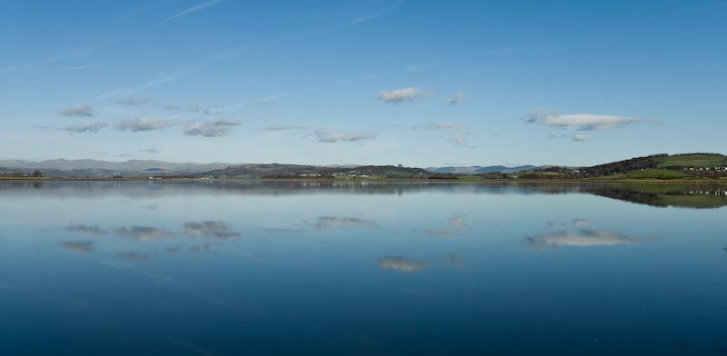
View across Morecambe Bay to Grange © Dave Willis mountainsportphoto.com

Coastal Partnerships Network
Annual Forum 2014

4th & 5th November 2014
Grange-over-Sands, Cumbria

Why hold this conference? The CPN Annual Forum is the national continuing professional development for Coastal Partnership Officers and members of their Steering Groups or Boards. It provides up to date information on the latest legislation and key issues affecting or affected by coastal management and helps to showcase different aspects of the work of coastal partnerships to inspire others. It also serves as the key networking event for CPN members and partner organisations, enabling them to build links and benefit from shared experience on a national scale.

What will you get out of the conference? You will gain a greater understanding of some of the hot topics in coastal management and have an opportunity to influence the future development of the Coastal Partnerships Network.

Who should attend? Coastal Partnership Officers from across the UK, their Board and Steering Group members and the organisations that work in partnership with them or that aspire to work in partnership at the coast.

Costs: The fee is per delegate and includes both days of the conference, the field trip and a 3 course networking dinner at the conference hotel on the evening of the 4th. It does not cover accommodation. NGOs / Public Sector: £50; Private Sector: £75; Exhibitors (additional fee applies) get 1 free place. A £20 reduction is available for those not wanting dinner; but no reduction for attending only part of the event.

Venue & Accommodation: The Grange Hotel is situated just less than 5 minutes walk from Grange-over-Sands railway station. We have provisionally held a number of rooms at £74 single, £125 double/twin b&b for the nights of 3rd and 4th November (this rate is also available on 2nd for those also attending the NWCF’s Destination Coast! conference). Please book direct with the hotel 01539 533666 quoting ‘coastal conference’ to get these rates. Alternative accommodation is available nearby – see Visit Cumbria

Exhibitions, Delegate Pack Inserts and Sponsorship: Opportunities exist, including cost savings for exhibiting at both events

Organised by the Coastal Partnerships Network CPN is a not-for-profit umbrella body bringing together coastal partnerships across England and representing their interests at national level. See www.coastalpartnershipnetwork.org.uk for our action plan and information on coastal partnerships across the England. The current Chair is Niall Benson, Durham Heritage Coast and the Secretariat/Treasurer is provided by Caroline Salthouse, North West Coastal Forum.

Destination Coast! Monday 3rd Nov – the North West Coastal Forum’s biennial coastal conference
Why not make the most of your visit to the North West and register for Destination Coast! which takes place on Monday 3rd November at the same venue and shares the field trip. Cost saving opportunities exist for organisations exhibiting at both events. See the North West Coastal Forum website for details or contact Caroline on 0151 934 2966.
Registration Form
Coastal Partnerships Network Annual Forum 2014
4th & 5th November 2014, Grange-over-Sands

Places are limited and will be allocated on a first come first served basis. Return your form early to ensure your place.

Please complete 1 form for each delegate in block capitals and return before 22nd October to:

Caroline Salthouse, North West Coastal Forum, Sefton Council, Magdalen House, 30 Trinity Road, Bootle L20 3NJ

Telephone: 0151 934 2966 Email: info@nwcoastalforum.org.uk

Confirmation and further details will be sent out 10 working days before the event.

Delegate Name:
Job title:
Organisation:
Address:

Telephone: Email:
To assist partnership building we would like to include your email address on the delegate list. Is this OK? Yes / No

If not already on the CPN mailing list do you want to be included on it? Yes / No
(details will never be shared with other organisations without first seeking your explicit consent)

Please indicate any special dietary or other requirements in the space below:

Field Trip: The field trip is shared with the North West Coastal Forum’s Destination Coast! conference so it would
be helpful to know if you plan to join us on the morning of Tuesday 4th November to ensure we have enough transport. Yes / No

Exhibition / delegate pack inserts (additional cost may apply): Please send me further details Yes / No
Paying exhibitors will receive 1 delegate place free

Please invoice me for £

- NGOs / Public Sector: £50; Private Sector: £75
- £20 reduction on either rate if you do not attend the Networking Dinner
- Exhibitors please call/email Caroline to discuss as exhibition charges include 1 free delegate place
- If you wish to pay for more than one delegate please call/email Caroline to discuss
- Please note there is no reduction for attending only part of the event (including the field trip)
- Refunds, minus a £10 administration charge, will only be issued to delegates cancelling more than 7 working days before the event; substitutes will be accepted but where possible 7 days advance notice should be given.

Purchase order or reference number:
IMPORTANT: Purchase orders should be made out to Sefton Council who will issue the invoice on our behalf

Invoice name and address and contact person (including telephone) if different from above:

