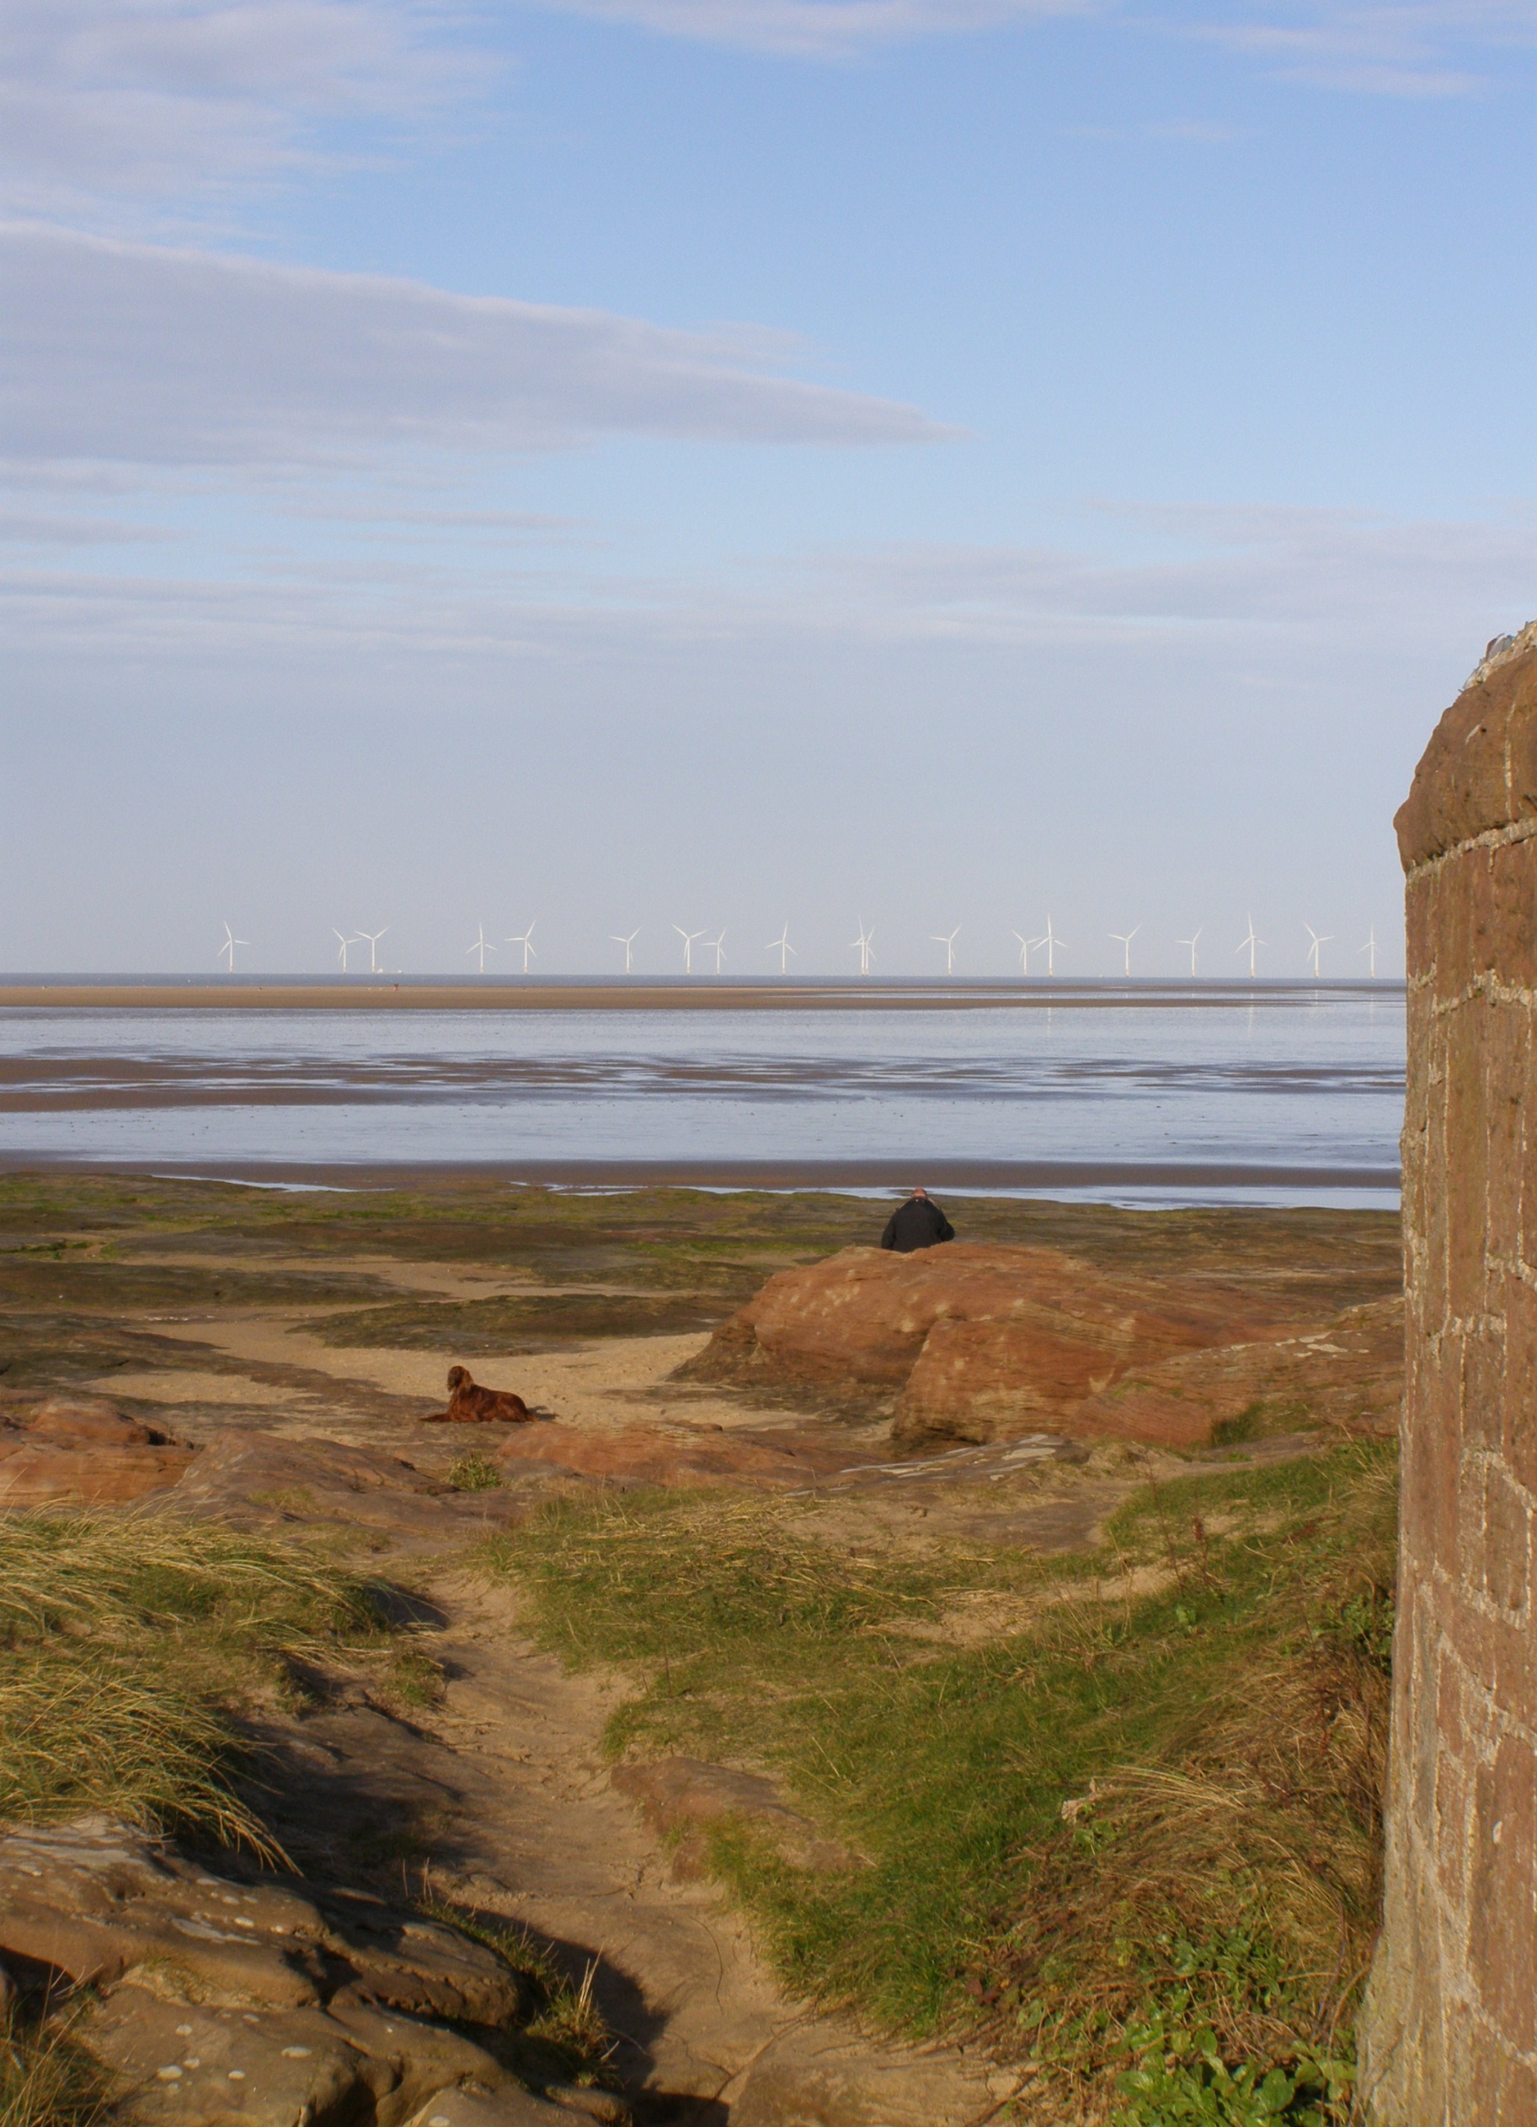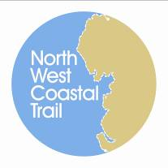

**Event Summary**

**3rd December 2013**

**Imperial Hotel, Blackpool**

**Funding Coastal Access...**

Contents

1. Introduction 2

2. Outputs of Workshop 3

2.1. County Region: Merseyside and Cheshire 4

2.2. County Region: Lancashire 7

2.3. County Region: Cumbria 11

2.4. Additional Comments 13

3. Conclusion and Next Steps 13

Appendix A: Event Programme 16

Appendix B: Delegates 17

*Photo credits: Unless stated otherwise all photographic images used in this report are © Dave Willis mountainsportphoto.com*

*Front cover image © Caroline Salthouse*

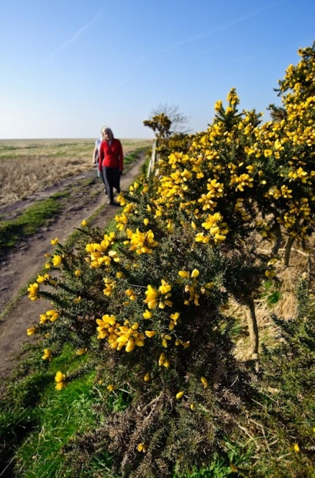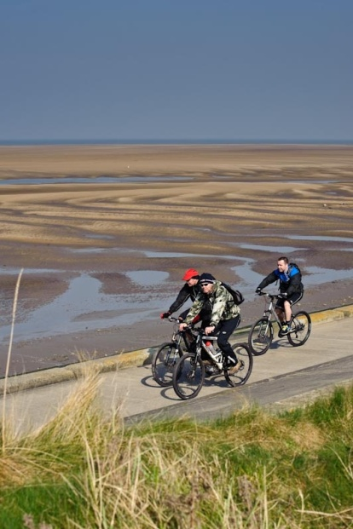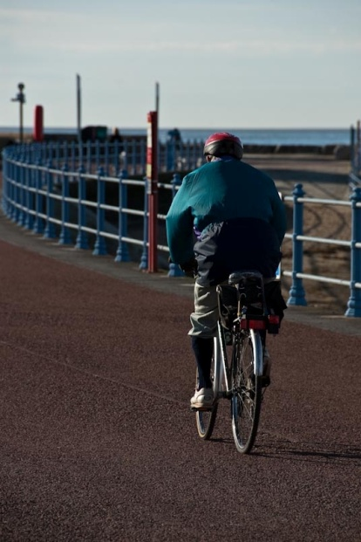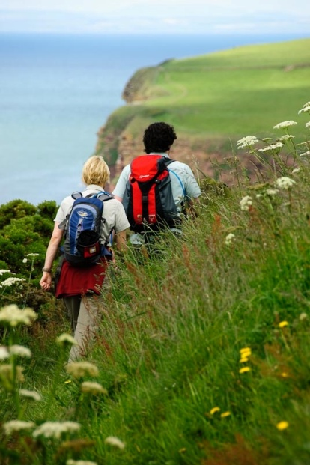

# 1. Introduction

The North West Coastal Trail Steering Group – a group established by the North West Coastal Forum to take forward an ambitious project to create a multi-use coastal trail from Chester to Carlisle linking together the natural, cultural and historical assets of the North West coast – held a one-day event on the 3rd December at the Imperial Hotel in Blackpool. The event was established to:

* Provide an update on funding opportunities for coastal access.
* Explore possibilities for collaborative bids to progress coastal access across administrative boundaries.
* Provide an opportunity to network and exchange information on coastal access improvements on the North West Coast
* Update delegates with the progress on national coastal access in Cumbria.

The event was also designed to explore and help answer the following questions:

**Question 1. What funding sources are potentially available for the project?**

* Have any funding pots been missed?
* What areas do they cover?
* What themes do they have?
* Are there any key constraints or previous experience to share?

**Question 2. Are there any access bids already being developed?**

* What are the current funding sources?
* What areas do they cover?
* What are the current themes?
* Which people/organisations are involved or taking a lead?

**Question 3. Are there any ambitions for a new bid or several bids?**

* What needs funding and from which source?
* Where is it and what geographic area should the bid cover?
* Which people/organisations should be involved?

The event was aimed at Local Authority Access Officers, elected members, Local Access Forum members and interest groups such as Ramblers, British Horse Society and Sustrans.

It took the form of a one day workshop with presentations and break out sessions designed to capture what is already taking place to further access on the North West coast and future opportunities and priorities for access.

# 2. Outputs of Workshop

The following section presents the results and recommendations from the questions considered for moving “Funding Coastal Access” forward within each county region. The results presented are from the following questions:

* **Question 1. What funding sources are potentially available for the project?**
* **Question 2. Are there any access bids already being developed?**
* **Question 3. Are there any ambitions for a new bid or several bids?**

The results are presented in an open format to enable amendments for any new updates and developments. Any updates or developments can be forwarded to the North West Coastal Forum Secretariat at [info@nwcoastalforum.org.uk](mailto:info@nwcoastalforum.org.uk), see *Section 3: Conclusion and Next Steps* below.

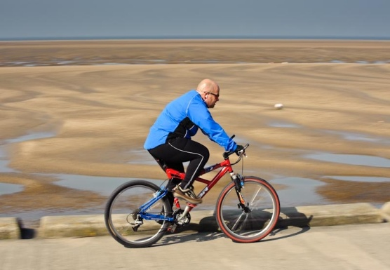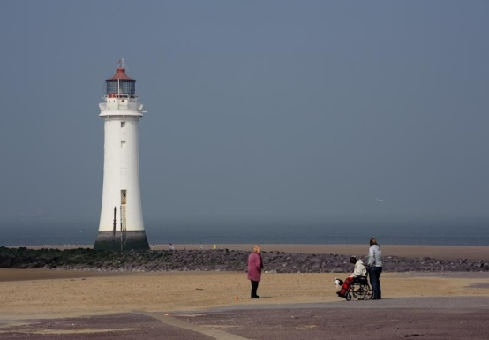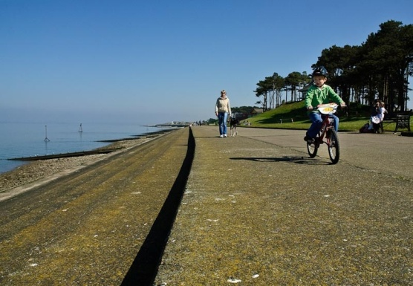

### 2.1. County Region: Merseyside and Cheshire

|  |  |  |  |
| --- | --- | --- | --- |
| **Question 1. Any other funding sources for Access?** | | | |
| **Funding Source** | **Any particular themes e.g. heritage, health** | **Other information e.g. timescales funding limits, etc.** | **Any Experience to share** |
| **North West Wide** | | | |
| Paths for communities | Multi use paths  Access Paths | Low value bids | Difficult to bid for? (too many applicants)  Only new access  Need large/strong public right of way team |
| Health Budgets | Health walks | Potentially large amounts. Need health specialists | Useful in deprived areas?  Councils promote health message  NICE report – evidence! |
| Sport England  British Cycling | Activity, Sports,  Competition | Lottery linked | Need ‘sport’ element  Development plans |
| Other energy schemes | Access  Recreation | Future funding? | Major international projects |
| **Nationwide** | | | |
| Department for Transport (DfT) links to communities | Community access | - | - |
| Environment Agency | Protecting waterways | - | - |
| United Utilities (e.g. funding community activities) | Access  Flood relief | - | - |

|  |  |  |  |
| --- | --- | --- | --- |
| **Question 1 (cont). Any other funding sources for Access?** | | | |
| **Funding Source** | **Any particular themes e.g. heritage, health** | **Other information e.g. timescales funding limits, etc.** | **Any Experience to share** |
| **Locally across the Nation** | | | |
| Local Sustainable Transport Fund (LSTF) | Walking/cycling | - | - |
| CABE | Visitor numbers/tourism | - | - |
| Arts Council | Visitor numbers/tourism  community engagement | - |  |
| European Regional Development Fund (ERDF) | - | - | - |
| Royal Society of the Protection of Birds (RSPB) | - | - | - |
| **Nationwide (10 miles from a land fill site)** | | | |
| Waste Recycling Environmental Limited (WREN funding – land fill sites) | Access and conservation | - | - |
| Landfill tax | Access and conservation | - | - |

|  |  |  |  |
| --- | --- | --- | --- |
| **Question 2. Access bids already being developed?** | | | |
| **Funding Source?** | **Any particular themes? e.g. heritage health** | **Lead organization and others involved?** | **Any scope for new partners?** |
| **Liverpool and Halton** | | | |
| Section 106 Speke/Garston coastal reserve | - | - | - |

|  |  |  |  |
| --- | --- | --- | --- |
| **Question 2 (cont). Access bids already being developed?** | | | |
| **Funding Source?** | **Any particular themes? e.g. heritage health** | **Lead organization and others involved?** | **Any scope for new partners?** |
| **Liverpool** | | | |
| Access bids + community facilities | - | - | - |
| **Sefton** | | | |
| Coastal footpath work in Sefton | - | - | - |
| **Based on their own land holdings** | | | |
| Landowners – Peel, National Trust, Network Rail, Cllrs Neighbourhood | Improving local areas by residents | - | - |
| Lottery | Heritage, sports, Arts etc | - | - |
| Local Police – Property Act and Chief Constables Fund | Community security + access e.g. beach activities | - | - |
| Sport England | Access to sport and facilities | - | - |
| Section 106 + other development lands | Infrastructure/open space/access improvements | - | - |

|  |  |  |  |
| --- | --- | --- | --- |
| **Question 3. Any ambitions for a new bid or several bids?** | | | |
| What needs funding? | Suggested funding sources, if any? | Suggested themes? e.g.heritage, health, muti-use etc.... | Which organisations should be involved |
| **South Liverpool – Halton Liverpool airport area** | | | |
| Merseyway – Liverpool Airport up to Halton + links to the routes at Garston Docks | Tried [sp?] coastal comms  Trying [sp?] Peel + Developer contributors + National Trust | - | Tom from sailing club, NT, Peel Holdings, Ramblers |

### 2.2. County Region: Lancashire

|  |  |  |  |
| --- | --- | --- | --- |
| **Question 1. Any other funding sources for Access?** | | | |
| **Funding Source** | **Any particular themes e.g. heritage, health** | **Other information e.g. timescales funding limits, etc.** | **Any Experience to share** |
| **North West Wide** | | | |
| Paths for communities | Multi use paths  Access Paths | Low value bids | Difficult to bid for? (too many applicants)  Only new access  Need large/strong public right of way team |
| Health Budgets | Health walks | Potentially large amounts. Need health specialists | Useful in deprived areas?  Councils promote health message  NICE report – evidence! |
| Sport England  British Cycling | Activity, Sports,  Competition | Lottery linked | Need ‘sport’ element  Development plans |
| Other energy schemes | Access  Recreation | Future funding? | Major international projects |
| **Nationwide** | | | |
| Department for Transport (DfT) links to communities | Community access | - | - |
| Environment Agency | Protecting waterways | - | - |
| United Utilities (e.g. funding community activities) | Access  Flood relief | - | - |

|  |  |  |  |
| --- | --- | --- | --- |
| **Question 1 (cont). Any other funding sources for Access?** | | | |
| **Funding Source** | **Any particular themes e.g. heritage, health** | **Other information e.g. timescales funding limits, etc.** | **Any Experience to share** |
| **Nationwide (10 miles from a land fill site)** | | | |
| Waste Recycling Environmental Limited (WREN funding – land fill sites) | Access and conservation | - | - |
| Landfill tax | Access and conservation | - | - |
| **Locally across the Nation** | | | |
| Local Sustainable Transport Fund (LSTF) | Walking/cycling | - | - |
| CABE | Visitor numbers/tourism | - | - |
| Arts Council | Visitor numbers/tourism  community engagement | - | - |
| European Regional Development Fund (ERDF) | - | - | - |
| Royal Society of the Protection of Birds (RSPB) | - | - | - |

|  |  |  |  |
| --- | --- | --- | --- |
| **Question 2. Access bids already being developed?** | | | |
| **Funding Source?** | **Any particular themes? e.g. heritage, health** | **Lead organization and others involved?** | **Any scope for new partners?** |
| **Lytham** | | | |
| Land Registry (Lytham) Developer contribution (re 300m approx) | Coastal access link | **Lead:** Fylde BC (coastal authority)  **Other:** Friends of the Estuary (Lytham) | Natural England/Environment Agency |

|  |  |  |  |
| --- | --- | --- | --- |
| **Question 2 (cont). Access bids already being developed?** | | | |
| **Funding Source?** | **Any particular themes? e.g. heritage, health** | **Lead organization and others involved?** | **Any scope for new partners?** |
| **Lytham (cont)** | | | |
| Heritage Lottery and Coastal Communities re Mussels tanks/Scruples Lytham | Heritage  Public Access  Children’s Play Area | Civic Society  Park View  For You | - |
| **Promenade – Fleetwood** | | | |
| Coastal communities (bid submitted round) | Environmental enhancement and job creation | Lead: Wyre BC  Other: Other partners, local businesses and voluntary groups | - |
| **Fairhaven Lake** | | | |
| Heritage Lottery £2 million | Heritage - restore lake + infrastructure  - Japanese | **Lead:** Fylde BC  **Other:** RSPB  Ribble Cruising Club  Sea Scouts | - |
| **Wyre coastal path** | | | |
| Lancashire Env. Fund/Private trusts | Environmental improvements/  Coastal access/  Ecology | **Lead:** Lancashire CC  **Other:** Groundwork  Wyre BC and private land owners | - |

|  |  |  |  |
| --- | --- | --- | --- |
| **Question 3. Any ambitions for a new bid or several bids?** | | | |
| **What needs funding?** | **Suggested funding sources?** | **Suggested themes? e.g. heritage, health, multi-use etc...** | **Which organisations should be involved?** |
| **West Lancashire and Hesketh Bank** | | | |
| Flood risk.  Access/Railway Bridge £3m.  Footpaths (Sefton interested) | Business, 106 and farmers - Fracking well, Booths, Agriculture  Heritage Lottery  Rivers  LTP  ERDF – Interreg  West Lancashire railway | Multi-use  Economy  Community link  Social  Heritage  Old Brick Works Shrimping  Weaving Mill  Canal | LA (LCC) /EA/RSPB/NE  Investors: Business  Housing 500 houses – private  Planning  Transportation  NFU |
| **Lytham & St Annes** | | | |
| Island development regeneration | Developer  Sea defence (Defra) + match + health/heritage/arts  Coastal communities? | Multi-use  Tourism/hotel | Fylde BC  include planning + regeneration sections + engineering  + Princes Trust/businesses |
| **Link whole of Fylde & Wyre coastline. Floodbanks Lytham/Warton to Preston** | | | |
| Missing links in coastal path from Preston to Fleetwood | Sea defence funding (Defra) + match heritage, art/grants health | Sea defence, Heritage, Arts and community/health | Landowners essential.  All local authorities. voluntary groups. EA/River Trusts.  RSPB / Natural England |
| **Fleetwood Docks to Knott End** | | | |
| Coastal Defence Scheme Wyre Estuary. Fleetwood docks to Knott End | Sea defence  Defra  Health/Arts/Heritage | Sea defence  Heritage  Arts  Access/Community | Wyre BC |

### 2.3. County Region: Cumbria

|  |  |  |  |
| --- | --- | --- | --- |
| **Question 1. Any other funding sources for Access?** | | | |
| **Funding source?** | **Any particular themes? e.g. heritage, health etc...** | **Other information? E.g. timescales, funding limits etc....** | **Any experience to share?** |
| **West Cumbria** | | | |
| NDA (Sellafield)  (Nuclear De-commissioning Authority) | Access  Recreation | Future funding? | **-** |
| **North West Wide** | | | |
| Paths for communities | Multi use paths  Access Paths | Low value bids | Difficult to bid for? (too many applicants)  Only new access  Need large/strong public right of way team |
| Health Budgets | Health walks | Potentially large amounts. Need health specialists | Useful in deprived areas?  Councils promote health message  NICE report – evidence! |
| Sport England  British Cycling | Activity, Sports,  Competition | Lottery linked | Need ‘sport’ element  Development plans |
| Other energy schemes | Access  Recreation | Future funding? | Major international projects |
| **Nationwide** | | | |
| Department for Transport (DfT) links communities | Community access | - | - |
| Environment Agency | Protecting waterways | - | - |
| United Utilities (e.g. funding community activities) | Access  Flood relief | - | - |

|  |  |  |  |
| --- | --- | --- | --- |
| **Question 1 (cont). Any other funding sources for Access?** | | | |
| **Funding source?** | **Any particular themes? e.g. heritage, health etc...** | **Other information? e.g. timescales, funding limits etc....** | **Any experience to share?** |
| **Locally across the Nation** | | | |
| Local Sustainable Transport Fund (LSTF) | Walking/cycling | - | - |
| CABE | Visitor numbers/tourism | - | - |
| Arts Council | Visitor numbers/tourism  community engagement | - |  |
| European Regional Development Fund (ERDF) | - | - | - |
| Royal Society of the Protection of Birds (RSPB) | - | - | - |
| **Nationwide (10 miles from a land fill site)** | | | |
| Waste Recycling Environmental Limited (WREN funding – land fill sites) | Access and conservation | - | - |
| Landfill tax | Access and conservation | - | - |

|  |  |  |  |  |  |  |
| --- | --- | --- | --- | --- | --- | --- |
| **Question 2. Access bids already being developed?** | | | | | | |
| **Funding Source?** | **Any particular themes? e.g. heritage health** | | **Lead organization and others involved?** | | **Any scope for new partners?** | |
| **Morecambe Bay (Cumbria)** | | | | | | |
| Heritage lottery + coastal communities | Visitor economy, jobs, tourism | | - | | - | |
| **Arnside Viaduct (Cumbria)** | | | | | | |
| To be confirmed | Morecambe Bay Partnership | | - | | - | |
| **Question 3. Any ambitions for a new bid or several bids?** | | | | | | |
| **What needs funding?** | | **Suggested funding sources, if any?** | | **Suggested themes? e.g.heritage, health, muti-use etc....** | | **Which organisations should be involved** |
| **West Cumbria** | | | | | | |
| Estuary crossing – Cumbria?  *Comment:* Network Rail + Natural England senior managers need to talk “strategically” to ensure viaducts are made accessible | | - | | All | | CCC, NE, Network Rail |

### 2.4. Additional Comments

In addition to answering the questions above participants made some additional comments. These are reproduced below:

1. Pennine Bridleway was a high spec/over engineered. Do we need such high specs for trails?
2. Public Rights of Way Teams often don’t have the resource to help develop coastal paths
3. No money upfront from funders

# 3. Conclusion and Next Steps

Despite challenging economic times there is still a wide range of potential funding mechanisms for developing coastal access – on foot, on bike or by horse – and the associated infrastructure. Some of the funding sources identified may not have instantly obvious relevance to coastal access but thinking around the wider benefits opening up access can deliver, for example health and well being, natural or cultural heritage, community capacity building, job creation, can bring significant funding streams into play. Looking across borders – both local and national – and linking up with neighbouring authorities and other organisations may also provide access to new funding streams.

The North West Coastal Forum, through our longstanding ambition to create multi-use coastal access along the North West coast, has a role in helping to progress access improvements along the coast. To aid this it is intended that the tables above will be maintained as a ‘live’ information source and be updated at least quarterly.

**We need your help to do this!**

**If you are developing – or wish to develop or be involved in developing – a bid please contact the North West Coastal Forum Secretariat at** [**info@nwcoastalforum.org.uk**](mailto:info@nwcoastalforum.org.uk) **with the following information (brief outline):**

1. Contact person (name, telephone, email and organisation). This will remain confidential and not be included on the publicly available document.
2. Project name (or idea) and brief description including geographic area covered.
3. Lead partner and other partners stating whether there is potential for others to be involved or not or ideas for who might lead/be involved.
4. Possible additional benefits that could unlock funding such as health benefits, heritage interpretation, etc.
5. Any identified funding source or sources or ideas for funding sources.

**We are also maintaining a database of those wishing who would like to be put in touch with others in their area who come forward with access improvement ideas.** If you would like to be included – your details will not be shared with anyone without checking with you first – please send your contact details and the geographic area / type of access project you might be interested in being involved in.

The North West Coastal Forum is a non-profit, multi-sector stakeholder partnership which aims to promote and deliver integrated coastal zone management for the long term sustainability of the north west’s coast. The North West Coastal Trail project helps to meet all of its underpinning objectives, but in particular the one relating to improved recreational opportunities and visitor experience. For more information on the Forum see [www.nwcoastalforum.org.uk](http://www.nwcoastalforum.org.uk)

# Appendix A: Event Programme

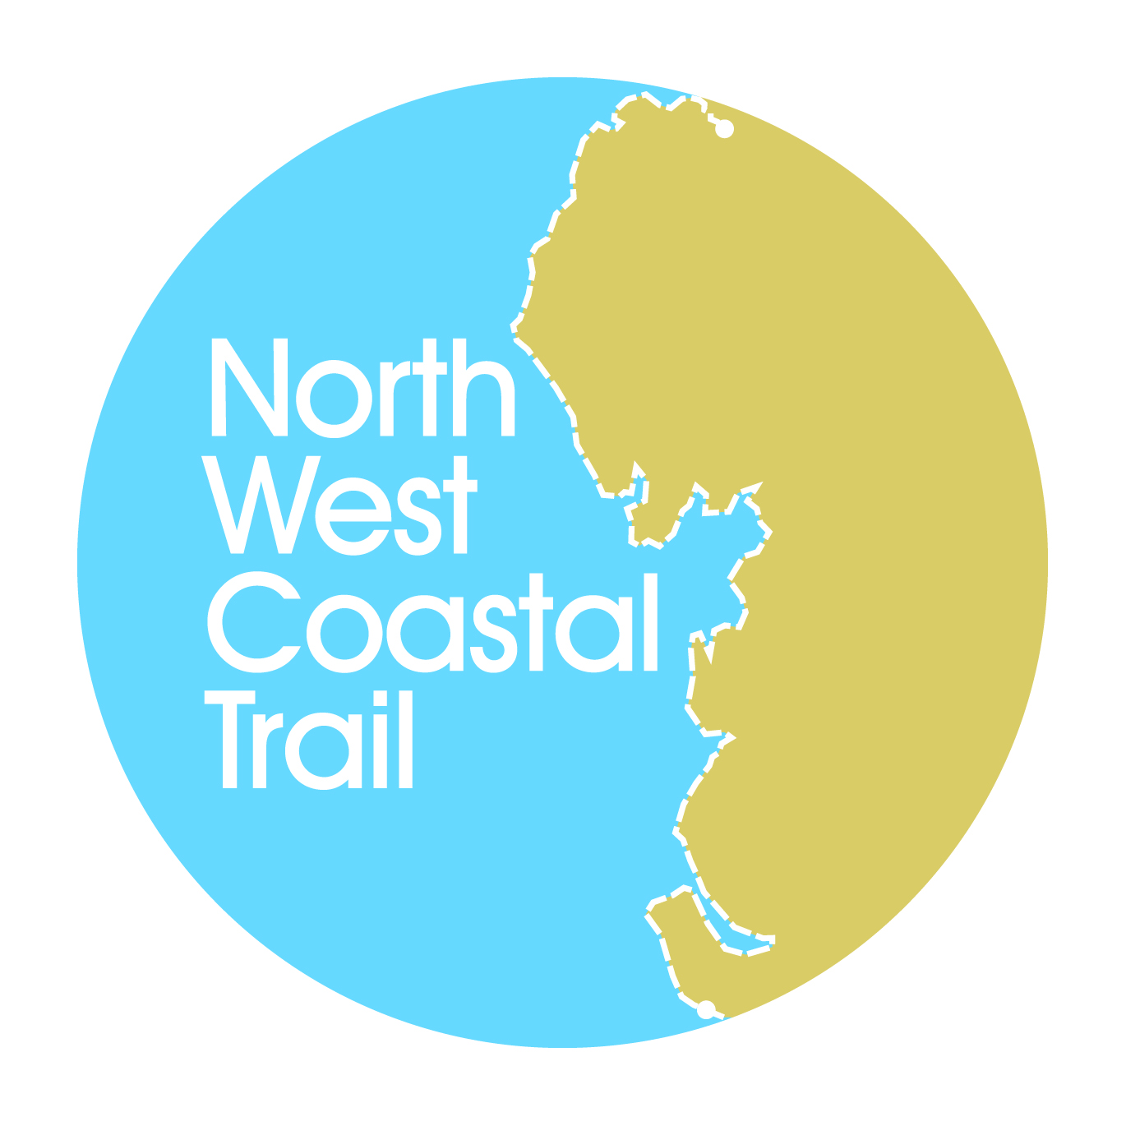

**Funding Coastal Access**

***A North West Coastal Forum***

***Networking and Communications Event***

**3rd December 2013, Imperial Hotel, Blackpool**

**Programme**

***Conference Chair: Sue Kidd, Chair of the North West Coastal Trail Steering Group***

**10:00 Registration and refreshments**

**10:30 Welcome & ambition for the North West Coast**

Sue Kidd, Conference Chair

**10:45 Update on roll out of National Coastal Access**

Danny Moores, Lead Advisor, England Coast Path Delivery Team (North West)

**11:10 Heritage Lottery Fund**

Maya Sharma, Development Officer, Heritage Lottery Fund North West

**11:35 Coastal Communities Fund & relevant examples**

Wil Woan, Big Lottery Fund

**12:00 The INTERREG Programme – opportunities for 2014 - 2020**

Caroline Salthouse, North West Coastal Forum

**12:20 Discussion**

**12:30 Lunch**

**13:30 VISIT Sefton and West Lancashire Local Improvement Grants**

Val Hough, Sustainable Visitor Travel Officer, Sefton Council

**14:20 Coastal Defence Schemes and Access Opportunities**

Carl Green, Head of Engineering, Wyre Borough Council

**14:40 Discussion**

**14:50 Refreshments**

**15:10 Workshop exploring funding opportunities for improving coastal access across the North West**

**15:40 Feedback and summing up**

**16:00 Event Close**

*NB it may be necessary for reasons beyond the control of the organisers to alter the speakers, timing or venue of the event*

# Appendix B: Delegates

**Funding Coastal Access**

**3rd December 2013, Imperial Hotel, Blackpool**

**Delegate List**

|  |  |
| --- | --- |
| **Name** | **Organisation** |
| Stephen Ball | Fylde Council |
| Janet Barton | Morecambe Bay Partnership |
| John Blackledge | Blackpool Borough Council |
| Alison Boden | Wyre Council |
| David Callan | Merseyside Local Access Forum |
| Nancy Corbin | Keep Britain Tidy |
| Neil Coventry | Liverpool City Council |
| James Daplyn | CAPITA Property & Infrastructure |
| Paul Drinnan | Fylde Council |
| Charles Ecroyd | Cumbria Local Access Forum |
| Frances Edwards | North West Coastal Forum |
| Neil Forbes | National Trust |
| David Gibson | Cumbria County Council |
| Carl Green | Wyre Council |
| Meg Green | Friends of the Estuary (Lytham) |
| Jim Green | Friends of the Estuary (Lytham) |
| Michael Helm | Lancashire Local Access Forum & The British Horse Society |
| Michelle Holroyd | Lancashire County Council |
| Val Hough | Sefton Council |
| Alice Irvine | SUSTRANS |
| Cllr Fred Jackson | Blackpool Council |
| Keith Johns | Ramblers Association |
| Sue Kidd | University of Liverpool |
| Dave McAleavy | Sefton Council |
| Danny Moores | Natural England |
| Clare Nolan-Barnes | Blackpool Borough Council |
| Michael Prescott | Lancashire Access Forum |
| Amy Ratcliffe | Blackpool Borough Council |
| Michael Ryan | Wyre Council |
| Caroline Salthouse | North West Coastal Forum |
| Maya Sharma | Heritage Lottery |
| Christine Smyth | Wirral Council |
| Karen Stringer | Wyre Council |
| Richard Toon | Lancashire Local Access Forum |
| Mrs R Tyson |  |
| Mr R Tyson |  |
| Wil Woan | Big Lottery |
| Tom Workman | Liverpool Sailing Club |