

Kate Hedges

Bathing Water Team

By email: bathingwater@defra.gsi.gov.uk

Nobel House

17 Smith Square

London

SW1P 3JR

30th September 2013

Dear Kate,

**Consultation on Length of the Bathing Season in England**

On behalf of the North West Coastal Forum I would like to thank you for the opportunity to comment on the consultation for the length of the bathing water season in England.

The North West Coastal Forum[1] is a multi-sector partnership working together across boundaries to deliver economic, environmental and social benefits for coastal communities in North West England. Our aim is to promote and deliver integrated coastal zone management in North West England to secure the long-term sustainability of the region’s coastal zone. Our vision of a sustainable future for the North West’s coast is underpinned by a range of objectives the most pertinent of which are improved recreational opportunities and visitor experience, improved well being of coastal communities and the economic potential of the coast achieved in ways which safeguard, enhance, restore and sustainably use our natural and cultural assets. As such we have a strong interest in bathing waters including issues affecting water quality, the management of bathing waters and bathing beaches and use by the public of those waters and areas of coastline and how that usage improves health and well being, visitor experience and the local economy.

In the North West a new partnership was launched just over a year ago, the Turning Tides Partnership, to work together on bathing water quality issues. They sought views from across the region on the bathing water season length and are submitting their response under separate cover. The North West Coastal Forum respects the process undertaken and the viewpoint reached by the Turning Tides Partnership, considering that it does represent a regional voice on this issue and would therefore like to express full support for their response, the key points of which are reiterated below with some additional comments:

**Season length options:** A combination of Option 2, i.e. a regional bathing season which runs to, at the latest, 5th September (so shorter than the current national season) and Option 1 enabling individual bathing water controllers to set their own season within the regional dates of 15th May to 5th September based on local current and historic usage.

**Advantages:** The suggested shorter season covers the main holiday periods from the late May Bank Holiday through to the end of the school holidays. Anecdotal information from some North West beach managers indicates there is little usage of bathing waters once the school holidays have ended although evidence may be needed to confirm this.

Allowing individual bathing waters to have shorter seasons within the parameters of a regional season provides flexibility to ensure that management and resources can be accurately tailored to local usage, whilst the overarching regional season provides the water company with set criteria and therefore confidence to enable investment in infrastructure to maintain or improve bathing waters as needed.

**Savings:**

Shorter bathing seasons will require reduced resource inputs for local authorities and private bathing water managers where beach management measures are implemented to help protect bathing water quality and may generate additional cost savings in terms of lifeguard provision, etc., however if a local authority decides to maintain the level of resource a shorter season would mean that more funds are available to spend on beach management and enforcement measures during high use periods for example helping to reduce health risks from sources such as dog fouling, beach litter, etc.

**Disadvantages and potential costs:**

Any change in season length will have implications for sampling and analysis. Clarification is needed on what the sampling and other regulatory impacts would be for a shorter season length but a process may need to be developed for bathing water controllers to follow if they wish to vary their locally established season because of any future change in local usage patterns; this process could then ensure sufficient resources are in place in good time to accommodate any needed change to the sampling regime.

If you need further clarification regarding any of the matters raised please do not hesitate to contact me.

Yours faithfully,

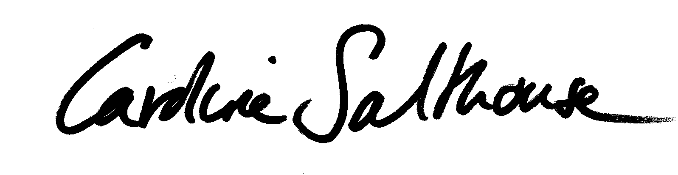

**Caroline Salthouse**

North West Coastal Forum Secretariat

1. The Marine Management Organisation has observer status on the North West Coastal Forum Management Board and as such has not participated in this consultation response.